
INSTALLATION MANUAL
Table of Contents

1. Applicable Version…………..…....……………………………….………………………...2
2. Installation kit..………………….……….……………………………………………………..3
3. Configuring worldline……………….…………………………………………………………4
4. Feature List……………….……………………………………………………………………..…5

Applicable Versions

Applications | Versions
Composer | 2.0.13
Laravel Installer | 4.2.5

Applications | Versions
PHP | ≥ 7.1.3, < 8.0
Laravel Framework | 5.8.38

Applications | Versions
PHP | ≥ 7.3.0, < 8.2
Laravel Framework | 8.44.0

Installation Kit
Please follow the given steps to install and run the worldline Payment Gateway module

1. Browse the provided zip folder and click it and download it .
2. Unzip that folder and place into www or htdocs folder
3. Install dependency through composer.
4. Open command prompt
5. Go to that folder “cd xampp\htdocs\unzip_folder”
6. Enter the command “php artisan serve”
7. You will get link copy that and open on your browser
8. for start of worldline kit http://<your-hostname>/start

Update kit
1. Go to the “\xampp\htdocs\unzip_folder” delete the old folder from htdocs and put the new folder there.
2. Follow the same process as mentioned above

Configuring worldline

- Go-to admin Page http://<your-hostname>/admin
- Scroll down. You will see worldline, Edit it
- Configure it as below:
Column Name | Description
Merchant Code | Enter Merchant Code
Salt | Enter Salt.
Payment Type | For Test mode Select ‘Test’ and for Live mode select ‘Live’
Merchant Scheme Code | Enter Scheme Code

4. Now click on “Submit” on the bottom-right corner.
5. worldline Payment Gateway is now configured & ready to use.

Advanced Configuration
There are also some advanced configuration options you may consider as shown below:
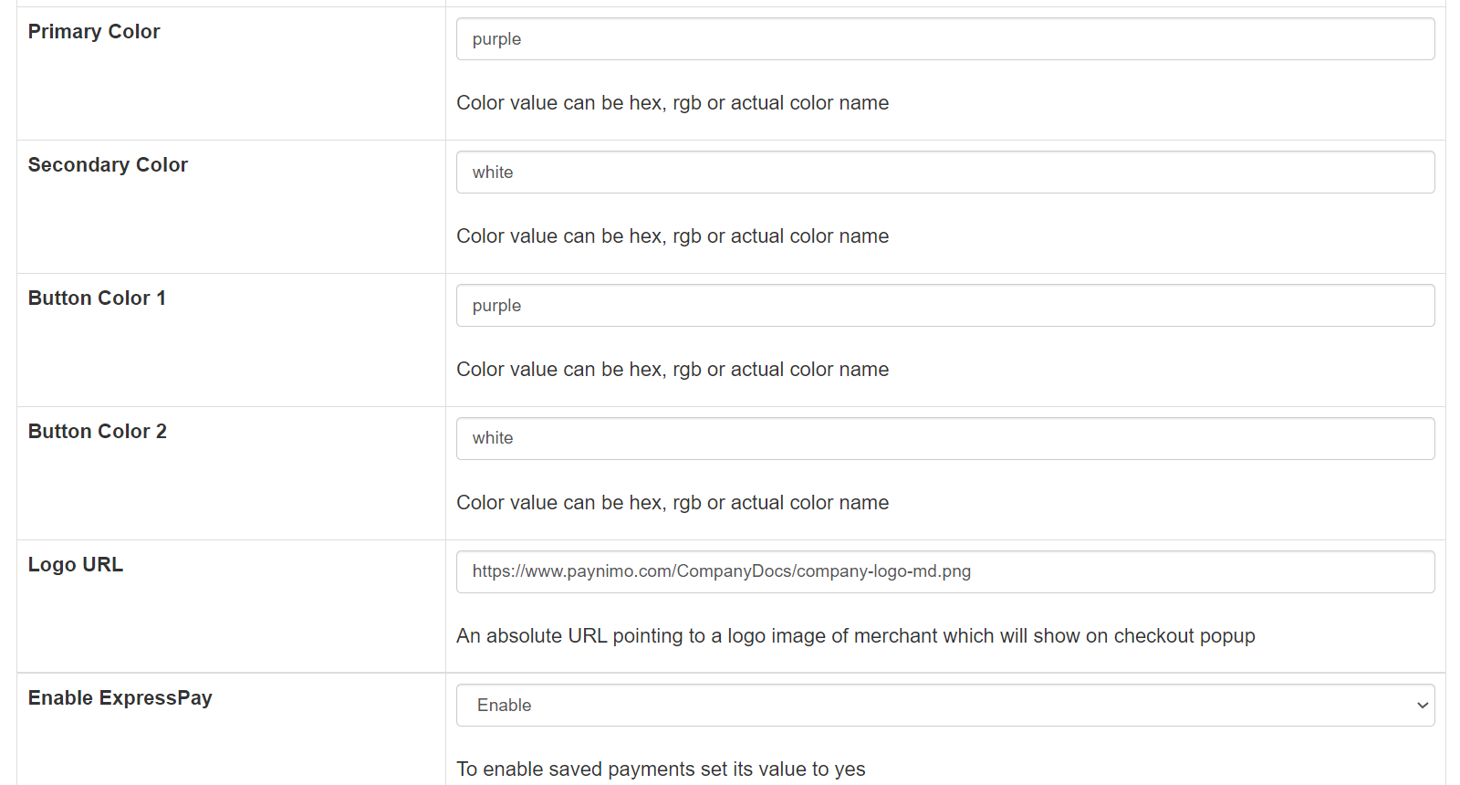

Features List
Online Transaction:
To make an online transaction go to http://<your-hostname>/start .

Dual verification of response:
We are validating responses with a hash value and call again Payment Gateway for dual verification from the payment gateway before updating to the order status.

S2S Verification
If we do not receive any response from the payment gateway then after 30 mins, we will get a response from the server and based on the response it will update order status. To configure S2S URL, contact prod team.
S2S url format : http://<your-hostname>/s2s?msg=
Example:
http://<your-hostname>/s2s?msg=0300|success|NA|12846079|470|1411243270|5.00|{itc:}{c[%E2%80%A6]f93dd72dc9c05fa0fa1601fb85d74d3e3177e7b2f3f111b08f542681077cq

MCG
It supports multi currency like INR & USD and a lot more can be added.

worldline Offline Verification
Merchants can verify the status of their payment by using the Payment Verification page. The payment verification page can be found at http://<your-hostname>/offline_verification
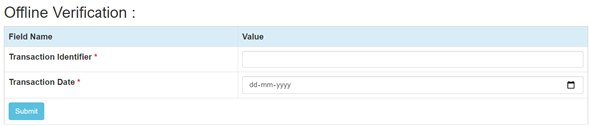

Reconciliation
Merchants can update the pending status of the order automatically if the payments are successful. This page can be found at http://<your-hostname>/reconciliation
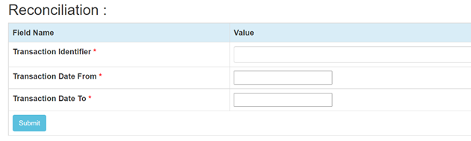

Refund
Merchants should be able to process the refund online for the order whose payment has been done via worldline. To refund an order go to http://<your-hostname>/refund
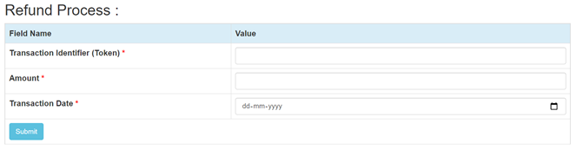

Embed Payment Gateway On Page
After enabling this setting, payment gateway displays like embedded on the page instead of pop-up so user experience would be good.

E-mandate/E-Nach/SI
Configuration
- Go-to http://<your-hostname>/admin
- Configure it as below

Column Name | Description
Enable eMandate/SI | “Enable” this flag to use E-mandate/E-nach/SI

- Now click on “submit” on the bottom.
- worldline Payment Gateway with E-mandate is now configured & ready to use.

Advanced Configuration
There are also some advanced configuration options you may consider as shown below:
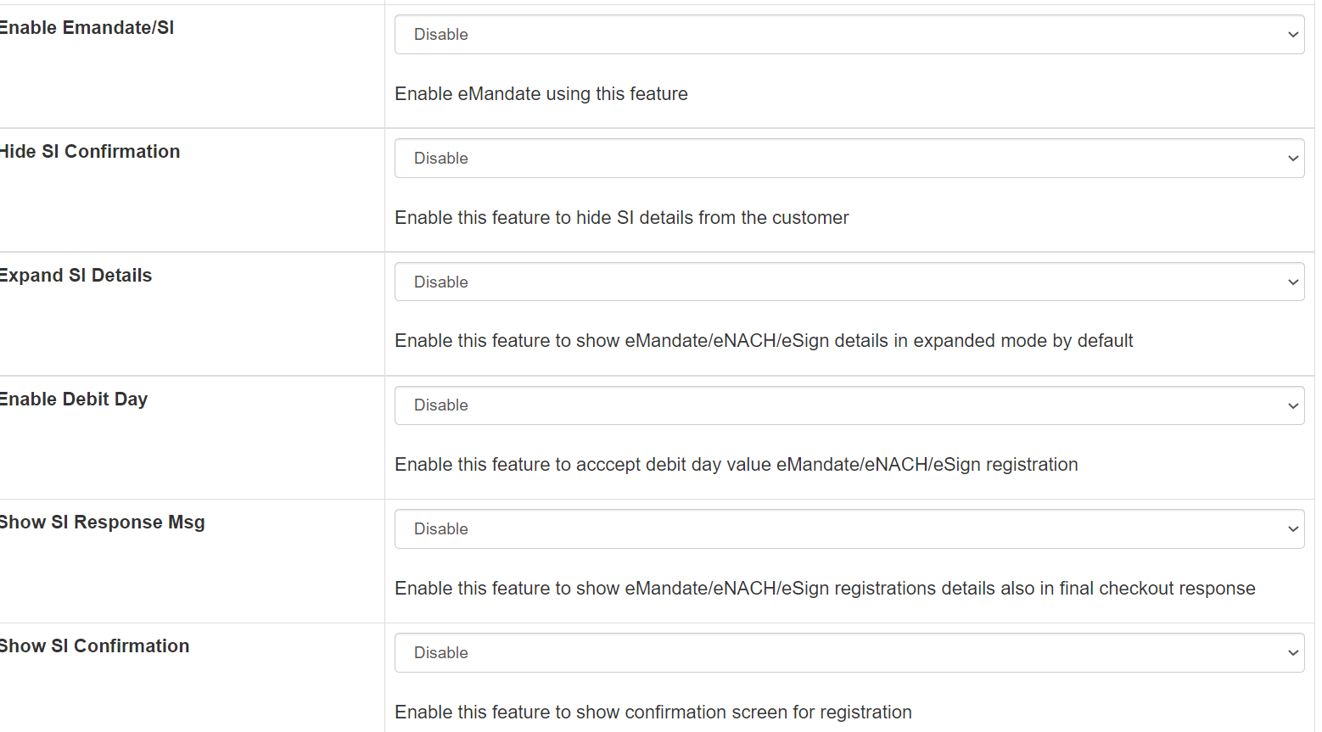

Mandate Registration

- Go-to http://<your-hostname>/start
- Fill the necessary fields for transaction
- Click on “Submit” button to get the E-mandate Pop up
- Fill the necessary fields on pop -up and click complete the transaction to register the mandate

Features List
Mandate Verification
Merchants can verify the status of their Registered Mandate/SI by using the Mandate Verification page.The Mandate verification page can be found at http://<your-hostname>/mandate_verification
We need to pass Consumer ID used in Online Transaction

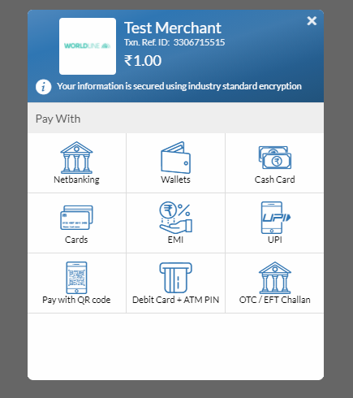

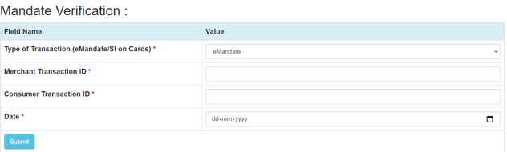
Transaction Scheduling
Merchants can Schedule their Transaction for Mandate/SI by using the Transaction Scheduling page. The Transaction Scheduling page can be found at
http://<your-hostname>/transaction_scheduling
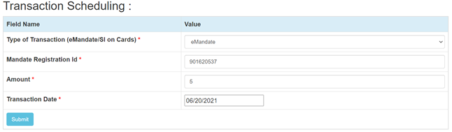

Transaction Verification
Merchants can verify the status of their Scheduled Transaction for Mandate/SI by using the Transaction Verification page. The Transaction Verification page can be found at
http://<your-hostname>/transaction_verification
We need to pass the Merchant Transaction Reg No given in Transaction Scheduling response
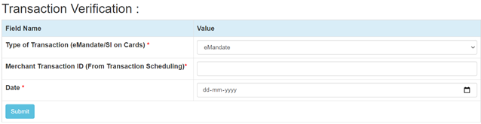

Mandate Deactivation
Merchants can deactivate the registered Transaction for Mandate/SI by using the Mandate Deactivation page. The Mandate Deactivation page can be found at
http://<your-hostname>/mandate_deactivation

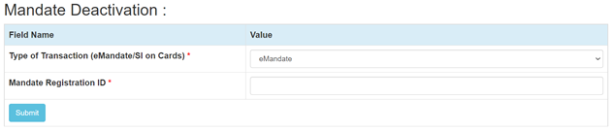

Stop Payment
Merchants can Stop the scheduled transaction by using the Stop Payment page. The Stop Payment page can be found at
http://<your-hostname>/stop_payment
We need to pass TPSL Transaction ID given in Transaction Scheduling response

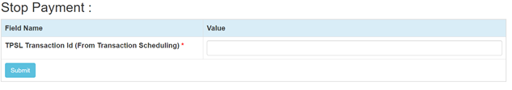
Documentation link
https://www.tecprocesssolution.com/proto/p2m/client/salt-based-documentation.htm#online

